**Case Study: Leveraging Artificial General Intelligence (AGI) in the Fashion Industry**Oluchi Obinna  
6252-ITAI-2372-Artificial Intel Applications  
April 19, 2025

### 

### 

### 

### 

### 

### 

### 

### 

### 

### 

### 

### 

### 

### 

### 

### 

### 

### 

### 

### **Introduction**

### Artificial General Intelligence (AGI) is the next frontier in technology. Unlike regular AI, which is designed to perform specific tasks, AGI is capable of understanding, learning, and applying knowledge across a wide range of tasks, similar to human intelligence. AGI could completely transform many industries, including healthcare, education, finance, and more. This case study will explore how AGI could revolutionize the fashion industry. The fashion industry is a massive global sector worth trillions of dollars, but it faces serious challenges, including overproduction, waste, fast-changing trends, and labor concerns. While AI has already made an appearance in areas like trend forecasting and virtual try-ons, AGI has the potential to take innovation to the next level. This study will examine how AGI could change the way clothes are designed, produced, and sold, while also considering the risks and ethical concerns that come with such powerful technology.

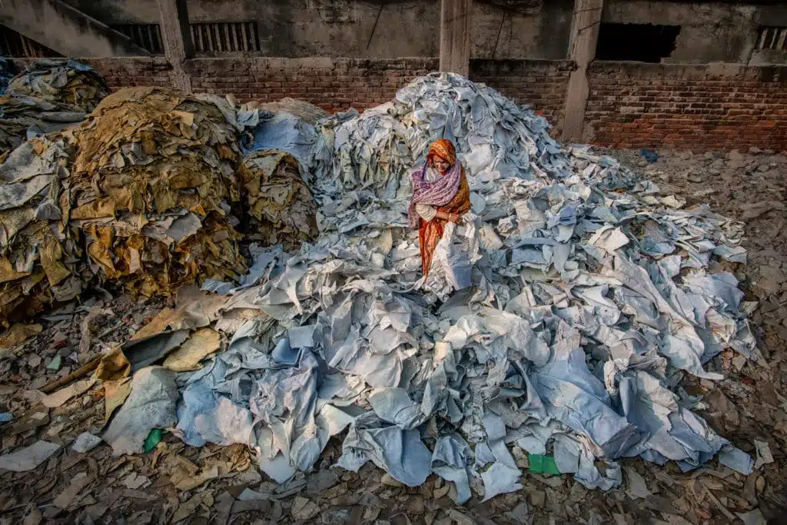

<https://earth.org/statistics-about-fast-fashion-waste/>

### **The Fashion Industry Now**

The fashion industry is fast-paced and highly competitive. According to Statista, the global apparel market is expected to reach over $2 trillion by 2028 (“Apparel Market”). Fashion companies need to respond quickly to changing trends, often releasing new collections every few weeks. This demand creates pressure on supply chains and can lead to overproduction, contributing to serious environmental issues.

Some major challenges the industry currently faces include:

* **Waste and Pollution**: The fashion industry is one of the biggest polluters in the world. The United Nations Environment Programme reports that it is responsible for 10% of global carbon emissions and 20% of wastewater.
* **Labor Concerns**: Many clothes are made in developing countries where workers are underpaid and work in poor conditions.
* **Trend Forecasting**: Companies often rely on trend reports and market research to guess what consumers will want. If they guess wrong, unsold inventory goes to waste.
* **Sizing and Returns**: Online shopping has led to high return rates, especially because of poor sizing or inaccurate product photos.
* **Supply Chain Complexity**: Fashion supply chains can be very complex, with many moving parts from fabric sourcing to delivery.

Some companies have started using AI to address these issues. For example, H&M uses AI to monitor store inventories and adjust production, and Levi’s uses algorithms to help customers find their perfect fit online. However, these systems are narrow in scope. AGI, with its ability to reason, plan, and adapt like a human, could create even bigger changes.

### **What Is AGI and How Is It Different from AI?**

Artificial Intelligence (AI) is already being used in many industries. It can analyze large amounts of data, make predictions, and automate tasks. But AI is usually limited to specific jobs. For example, an AI can help predict fashion trends, but it cannot also design clothes, run a marketing campaign, and manage a supply chain…at least, not all at once. AGI, or Artificial General Intelligence, is different. It is a form of AI that can perform any intellectual task that a human can do. AGI can learn, understand, reason, and solve problems across different domains without needing to be programmed for each specific task. In other words, AGI doesn’t just follow instructions- it can think for itself and apply knowledge in new ways. This makes AGI potentially more powerful than current AI, and it could completely reshape industries by becoming a central intelligent system that helps with everything from design to delivery.

### **Using AGI to transform the Fashion Industry**

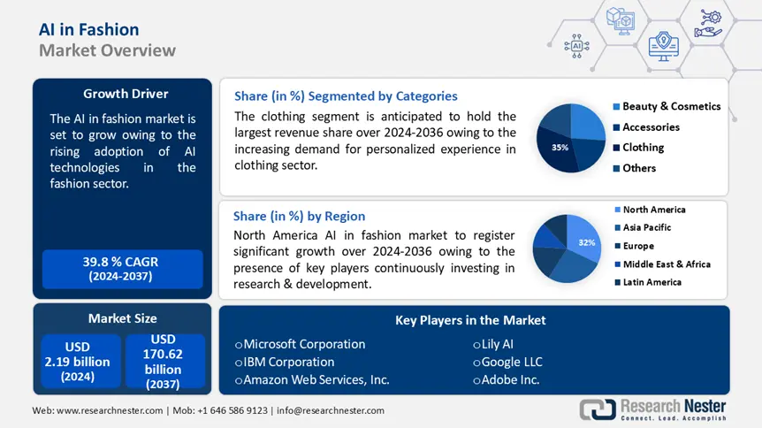

<https://www.researchnester.com/reports/ai-in-fashion-market/6296?>

#### **1. Design and Personalization**

AGI could analyze global data in real-time to understand what styles, colors, and materials are trending across different regions and cultures. Based on this, it could automatically design clothing lines tailored to specific markets or even individual customers. AGI could also collaborate with human designers by generating ideas, predicting consumer preferences, and suggesting improvements. For example, a fashion brand could input data about its brand identity, target audience, and sales history. AGI could then generate dozens of fashion sketches that align with the brand’s image and appeal to its customers.

#### **2. Smart Manufacturing**

Using AGI, factories could become fully automated. AGI could manage the entire production line- from sourcing sustainable fabrics to cutting, sewing, and packaging- while minimizing waste. It could also monitor machinery in real-time, schedule maintenance, and improve efficiency. It could also create “on-demand” production, where clothes are only made after a customer orders them. This would help reduce overproduction and the problem of unsold inventory.

#### **3. Supply Chain Optimization**

Managing a fashion supply chain is very complex. AGI could track raw materials, predict shipping delays, and find the fastest and most sustainable routes. It could respond instantly to disruptions (like weather or political unrest) and reroute deliveries to keep everything running smoothly. This would not only save money but also reduce the industry’s carbon footprint.

#### **4. Customer Experience and Virtual Try-Ons**

#### AGI could create virtual shopping assistants that understand customer preferences and body types to recommend perfect outfits. It could also run virtual try-on systems that show exactly how clothes will look and fit. This would reduce the number of returns, which is a big problem in online shopping. AGI could even offer custom-tailored clothing based on 3D scans of customers, making fashion more inclusive for all body types.

#### **5. Marketing and Trend Forecasting**

AGI could analyze millions of posts on social media, fashion shows, and online stores to detect emerging trends before they go mainstream. Brands could then respond quickly with new designs and marketing campaigns. It could also help brands create personalized advertisements for each customer, improving engagement and sales.

### **Anticipated Benefits**

The benefits of using AGI in the fashion industry include:

* **Increased Efficiency**: AGI could automate and optimize processes across design, production, and delivery.
* **Reduced Waste**: On-demand manufacturing and better predictions would reduce overproduction and pollution.
* **Better Customer Satisfaction**: Personalized experiences and perfect fits would improve customer happiness and reduce returns.
* **Innovation**: AGI could help design groundbreaking styles and create fashion that responds to real-world needs.
* **Sustainability**: Smarter resource use and sustainable practices would be easier to achieve.

### **Risks and Ethical Concerns**

While AGI offers exciting opportunities, it also comes with serious risks such as:

* **Job Loss**: Automating design and manufacturing could lead to layoffs, especially in countries where fashion labor is a major source of income.
* **Bias and Representation**: If AGI is trained on biased data, it could reinforce harmful stereotypes or exclude certain groups from fashion innovation.
* **Data Privacy**: AGI systems would need access to personal data to offer personalized experiences. This could raise privacy issues if not handled carefully.
* **Control and Decision-Making**: If AGI makes important business decisions, who is held accountable when mistakes happen?
* **Overdependence**: Relying too much on AGI might reduce human creativity and craftsmanship in fashion.

To address these concerns, it is important to design AGI systems that are transparent, fair, and guided by human values.

### **Conclusion**

AGI could be one of the most powerful tools ever created, and its impact on the fashion industry could be massive. From designing custom clothing to running entire supply chains, AGI has the potential to solve many of the industry’s biggest problems, including waste, inefficiency, and poor customer experiences. However, it must be noted that AGI also raises ethical and social questions. It is important to develop AGI in ways that protect jobs, ensure fairness, and respect human creativity. If done right, AGI could help build a fashion industry that is smarter, more inclusive, and more sustainable. The future of fashion may not be just about what we wear, but how intelligently we create and experience it. It's about working smarter, not harder.

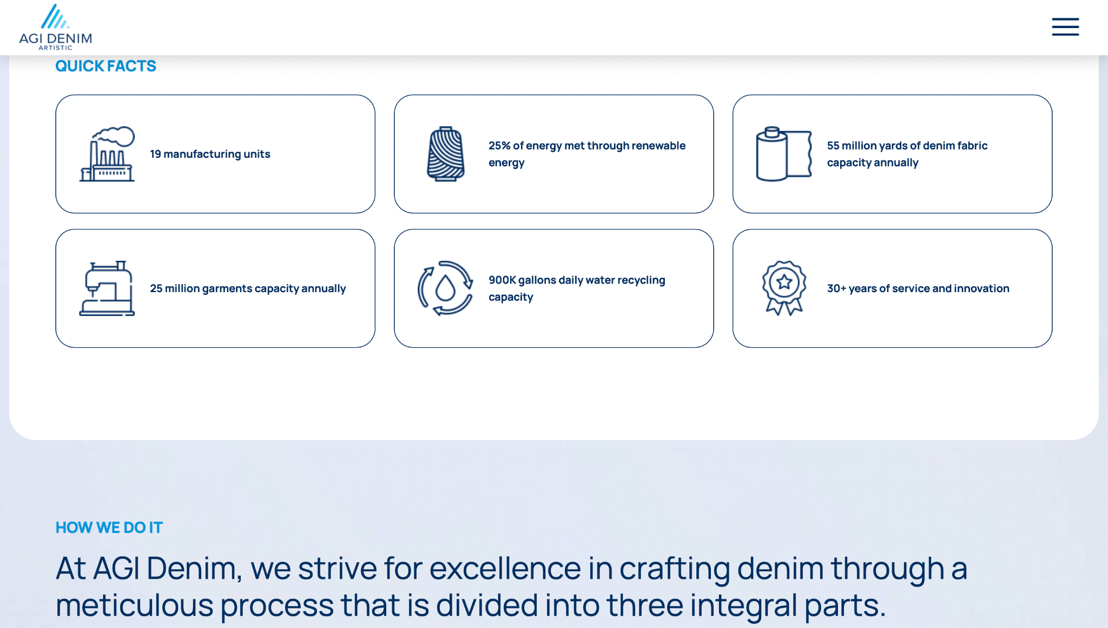 [https://agidenim.com/](https://agidenim.com/?)

### **References**

“Apparel Market - Worldwide.” *Statista*, 2024, <https://www.statista.com/outlook/cmo/apparel/worldwide>.

“Putting the Brakes on Fast Fashion.” *United Nations Environment Programme*, <https://www.unep.org/news-and-stories/story/putting-brakes-fast-fashion>.

Marr, Bernard. “How AI Is Transforming the Fashion Industry.” *Forbes*, 17 May 2021, <https://www.forbes.com/sites/bernardmarr/2021/05/17/how-ai-is-transforming-the-fashion-industry>.

Vincent, James. “The Important Difference Between Generative AI and AGI.” *LinkedIn*, 8 Mar. 2023, <https://www.linkedin.com/pulse/important-difference-between-generative-ai-agi-bernard-marr-nynee>.

“Artificial Intelligence in Fashion Market Size.” *Market Research Future*, 2024, <https://www.marketresearchfuture.com/reports/ai-in-fashion-market>.